### UC8: Approve an agreement

This function is to approve an agreement which have status is waiting approval.

#### Actors in UC8

* Dealer Proposer
* CSM/ LSM
* System Administrator

#### Pre-condition

- After executing UC search agreement with “Awaiting” status then user selects an agreement to view it.

#### Functional description

|  |  |  |
| --- | --- | --- |
| ID | Description | Comments |
| UC8_001 | User selects the hyperlink to view the summary details of the agreement with “Awaiting” status. |  |
| UC8_002 | User reviews agreement details and clicks on “approve” button on View Agreement screen, application will update the agreement status to “Approved” |  |

#### UML Activity diagram



#### Screen flow

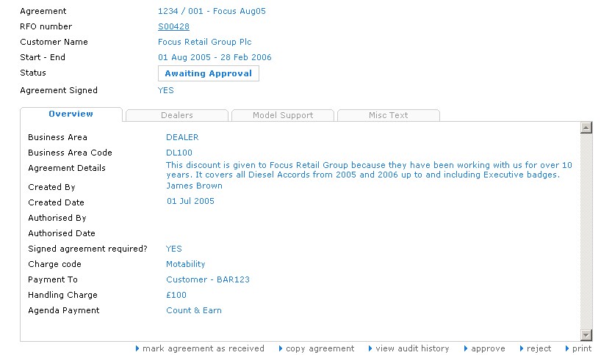

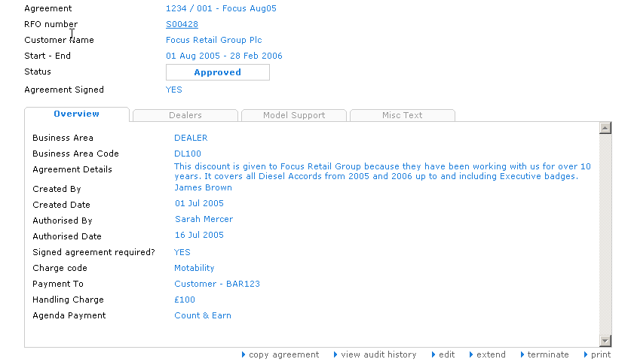

#### Data requirements

The same **Use case 6**